Title: **Biodiversity conservation in an uncertain world**

Authors: Richard Schuster a,b,*, Rachel Buxtona, Jeffrey O. Hansona, Allison D. Binleya, Jeremy Pittmanc, Vivitskaia Tullochd, Frank A. La Sortee, Peter H. Verburgf, Amanda D. Rodewalde,g, Scott Wilsona,h, Hugh P. Possinghami, Joseph R. Bennetta

Affiliations:

a Department of Biology, 1125 Colonel By Drive, Carleton University, Ottawa ON, K1S 5B6 Canada.

b Ecosystem Science and Management Program, 3333 University Way, University of Northern British Columbia, Prince George BC, V2N 4Z9 Canada.

cSchool of Planning, University of Waterloo, 200 University Ave W, Waterloo, ON, N2T 3G1, Canada

d Conservation Decisions Lab, Department of Forest and Conservation Sciences, 2424 Main Mall, University of British Columbia, Vancouver BC, V6T 1Z4 Canada.

e Cornell Lab of Ornithology, Cornell University, Ithaca, NY 14850, USA

f Institute for Environmental Studies, VU University Amsterdam, Amsterdam, The Netherlands

g Department of Natural Resources and the Environment, Cornell University, Ithaca, NY 14853, USA.

h Wildlife Research Division, Environment and Climate Change Canada, 1125 Colonel By Drive, Ottawa, Ontario, Canada, K1S 5B6

i Centre for Biodiversity and Conservation Science, University of Queensland, St Lucia, Queensland 4067, Australia

*Corresponding author: Department of Biology, 1125 Colonel By Drive, Carleton University, Ottawa ON, K1S 5B6 Canada. Email: [richard.schuster@glel.carleton.ca](mailto:richard.schuster@glel.carleton.ca), Phone: +1 250 631 8324, ORCID: 0000-0003-3191-7869

**First paragraph**

Protected areas are a key instrument in efforts to conserve biodiversity, yet limited governance1 and increasing pressure from land-use intensification2, and climate3 change risk are reducing protected area effectiveness. If international biodiversity goals4 are to be met, these risk factors must be considered in protected area planning. We included these three risks into a multi-objective spatial optimization to build on the existing protected area estate, aiming to conserve at least 30% of all of the world’s terrestrial vertebrates in just under 30% of the planet. We compared the amount of area in each country requiring protection under different risk scenarios. We discovered that incorporating these risks into conservation plans requires remarkably small (1%) increases in the amount of land we need to protect. Although the same 3.57 million km2  of land was identified as priority habitat for protection regardless of the risks included in our analysis, the risk of limited governance drove the greatest variation in the location and amount of land prioritized. In particular, conserving wide-ranging species required countries with relatively strong governance to protect more land when bordering nations with relatively low governance scores. Our results show that risk can feasibly be accounted for in global PA planning and emphasizes the importance of cross-jurisdictional conservation planning.

**Main text**

Protecting habitat is one of the best strategies for stemming the alarming decline in biodiversity5. As such, the cornerstone of the renewed global framework for biodiversity conservation aims to protect at least 30% of terrestrial land area by 20304. To identify areas of particular importance for inclusion in the expanding protected area network, current approaches rely on measures of regional biodiversity value and vulnerability4,6,7. This assumes that protected areas are permanent and their effectiveness is static. However, governance, land use intensification, and climate change pose risks to the future effectiveness of protected areas. For example: the quality of governance predicts investment in conservation8,9; political instability and corruption can reduce protected area effectiveness10; protected areas with more deforestation are at high risk of degazetting and project failure11; and increased extreme weather events cause population decline or extirpation for a variety of species12. Thus, to make effective use of limited conservation resources, planning for investment in protected areas must account for these risks13,14. We quantify how accounting for governance, land-use, and climate risks can influence decisions for protected area establishment at a global scale. We show how accounting for these risks can identify key areas that may be most resilient to future change, thus buffering biodiversity against risk.

We consider three broad categories of risk, which we define as pressures that increase the likelihood that protected areas will become ineffective for protecting biodiversity under future conditions: i) governance, ii) land-use, and iii) climate impacts. For governance risk, we use a national-scale metric that combines six governance indicators from the World Bank15: accountability, political stability, government effectiveness, regulatory quality, rule of law, and control of corruption (Figure S1). For land-use risk, we estimated the average change in biodiversity per land-use category using methods16 that model the risk of biodiversity loss for land systems due to agricultural expansion and intensification (Figure S2). For climate impacts risk, we use the duration of extreme heat events, calculated using a probabilistic framework that estimates the novelty of temperatures relative to historical year-to-year variation from 1979 to 2019 (Figure S3), identifying areas where heat events are likely to have the most significant effects on biodiversity17. We note that our specific metrics of risk are intended as examples, used to demonstrate the importance of considering governance, land use and climate change in combination. However, our approach is flexible and could incorporate other risk metrics with implications for biodiversity18.

We consider the influence of risk categories on allocating protection decisions at a global scale for all 30,930 known distributions of vertebrate species from the IUCN Red List of Threatened Species19 using a multi-objective optimization approach. To incorporate risk categories, we built on a classical problem formulation from the systematic conservation planning literature – the minimum set problem - where the objective is to reach species distribution protection targets, while accounting for one constraint such as land cost or area20–22. We expand this approach to include multiple objectives accounting for varying risk in the problem formulation, by treating each risk layer as a separate objective in the problem formulation23. We use a hierarchical approach that assigns a priority to each objective, and optimizes for the objectives in decreasing priority order. At each step, the approach finds the best solution for the current objective, but only from among those that would not degrade the solution quality for higher-priority objectives.

Because of the hierarchical structure, we created 16 planning scenarios, with solutions that account for all possible combinations of risk categories in each level of the hierarchy (Table S1). We then compared solutions with risks incorporated to a baseline scenario, representing the classical minimum area-based approach to solving conservation planning problems24. Because our scenarios were aimed at building on the current protected area portfolio globally, we incorporated current protected areas into our solutions. For each scenario we protect 30% of the range of all vertebrate species, which we use as an example that is broadly analogous to the more general 30% total area Convention on Biological Diversity (CBD) target24.

We found that the protected areas planning scenarios incorporating the three risk categories required only 0.9% more global area on average (0.34 – 1.14 %) than the baseline scenario to meet the target of protecting 30% of vertebrate habitat. Thus, accounting for key risks to protected area effectiveness to produce more resilient conservation networks will not substantially increase the global area required to meet 30% protection targets (Figure 1). Additionally, we found that all 16 scenarios reached their goals of 30% protection of each vertebrate species range without surpassing the 30% global area target that the CBD is currently considering in their post-2020 framework24. Of all scenarios, those including land-use risk required the greatest increase in global protected area, compared to scenarios only including governance and/or climate extreme risks (Table S1).

There was also considerable spatial overlap among scenarios, with the same 22 million km2 (6.9% of global land area) being prioritized for expansion of the current protected area system in at least eleven scenarios and 3.6 million km2 (2.4% of global land area) in all fifteen risk scenarios (Figure 2). These “no regrets” areas provide examples of places that should be priorities for international agencies aiming to maximize the resilience of protected area networks, as they are robust to assumptions of the relative importance of risk factors. Example countries that have contiguous areas of high overlap among scenarios are Canada, Egypt, Finland, Kazakhstan and Peru (Figure S4). There is some overlap among the priorities across scenarios within Conservation International’s global biodiversity hotspots25, but many high overlap areas lie either outside these hotspots (83.1%) or occur within small portions of the biodiversity hotspots likely because these areas are important to protect regardless of future risk (Figure S5).

We found substantial variation in some countries in the amount of area requiring protection when risks were introduced (Figure 3; Table S2). These differences were driven largely by governance (Figure S6). Countries with relatively high governance scores had greater area requiring protection under risk scenarios relative to the baseline scenario, especially when species were wider ranging and when neighbouring countries had low governance scores. Thus, risk is connected across jurisdictions, where planning scenarios favour protection of species in nearby countries with low governance risk (i.e., high governance scores). For example, many vertebrate species ranges span north-eastern Russia, Finland, and Sweden, with one of the most iconic being caribou (*Rangifer tarandus*), which has an IUCN conservation status of vulnerable. Because Russia suffers from low scores for ‘voice and accountability, rule of law, and control of corruption’ (Table S3), whereas Finland and Sweden have relatively high governance scores, the scenarios including governance pressures led to a selection of 99.4% and 48.9% of Finland and Sweden’s land areas respectively compared to the baseline scenario with 30.8% and 15.2% (Figure 4). These results do not mean the majority of land inside Finland needs to be protected to ensure the long-term persistence of caribou, but indicate that prioritizing areas in Sweden and Finland is predicted to be far less of a risk than areas in Russia.

Land-use and climate change also influenced variation in areas requiring protection above baseline. For example, large areas of Sierra Leone are experiencing high risk of biodiversity loss due to expanding intensive land-use practices (Fig. S2), whereas this same risk is lower in neighbouring Liberia. Scenarios including land-use risk selected 50.1% of the land area in Liberia compared to 21.9% in the baseline scenario (Figure 4). Large areas of Algeria are experiencing increasingly frequent extreme heat events (Fig. S3), whereas neighbouring Libya is not experiencing as many extreme heat events. Scenarios including climate impact risk have a selection of 30.8 in the Lybia land areas compared to the baseline scenario with 20.9% (Figure 4).

These results emphasize the importance of coordinated cross-jurisdictional conservation planning initiatives26 and identify countries where opportunities for collaboration would yield more resilient protected areas. To illustrate this point, we consider the Great Green Macaw (*Ara ambiguus*), with <2500 individuals remaining27 and a range that stretches from southern Honduras to western Colombia. Because Great Green Macaw habitat spans several countries differing in governance, land use, and climate risk, coordinated efforts between countries will be necessary for the species to persist in the future. For countries with a predominance of wide-ranging species whose ranges will be impacted by varying climate, land-use, and governance risk across borders, conservation projects can focus on cooperative governance frameworks28 (Figure 3).

In contrast, some countries at high risk from climate change, land-use, and low governance scores, but with high endemism, for example in northern Oceania, have a low difference between scenarios that incorporate risk. Given high and endemic biodiversity, and homogeneity of risk, these countries all require high rates of protection within their own borders. Moreover, some countries closer to reaching the CBD’s 30% land area protection target, for example Brazil, which already has 30.3% of its land area protected, had lower differences between scenarios that incorporate risk versus baseline, despite having high climate, land-use, and governance risk. This outlines the importance of further considering the effectiveness of existing protected areas in planning analyses, where pressure from cropland conversion in tropical protected areas has increased to similar rates outside protected areas29.

Previous work has incorporated risk factors analogous to those we used, including governance1,48, climate change3 and land-use change2,30. Yet, our results show that protected area expansion decisions can be profoundly influenced by all three risk factors. If data on risk alters the effectiveness of biodiversity protection, our results show that they should be used together to support decisions for resilient protected area networks. As an example, climate metrics such as disappearing climates31 might be relevant if the consideration is on small-ranged and threatened species. Our flexible framework and methods can allow conservation agencies looking to set priorities from the global to local scale and incorporate different metrics to explore the influence of individual parameters and metrics on decisions.

**Conclusion**

As conservation agencies look to secure new areas for protection, risk of future change will be particularly important as projected changes in climate32, land-use30, and socio-economic uncertainty can compromise protected area effectiveness. Our results show that protected area expansion decisions can be profoundly influenced by risk, particularly governance. Surprisingly, incorporating risk into decision-making adds <1% to the total global area required to meet biodiversity targets. Our results also emphasize the importance of cross-jurisdictional conservation initiatives, especially in adjacent countries sharing wide-ranging species where risk varies considerably from country to country. Considering risk in conservation decision-making will lead to more resilient and effective conservation plans into the future to help safeguard our planet’s biodiversity in the face of the current extinction and climate crises.

**Main references**

1. Mascia, M. B. & Pailler, S. Protected area downgrading, downsizing, and degazettement (PADDD) and its conservation implications. *Conservation Letters* **4**, 9–20 (2011).

2. Pouzols, F. M. *et al.* Global protected area expansion is compromised by projected land-use and parochialism. *Nature* **516**, 383–386 (2014).

3. Hoffmann, S., Irl, S. D. & Beierkuhnlein, C. Predicted climate shifts within terrestrial protected areas worldwide. *Nature communications* **10**, 1–10 (2019).

4. Zero draft of the post-2020 global biodiversity framework.

5. Watson, J. E., Dudley, N., Segan, D. B. & Hockings, M. The performance and potential of protected areas. *Nature* **515**, 67–73 (2014).

6. Brooks, T. M. *et al.* Global biodiversity conservation priorities. *science* **313**, 58–61 (2006).

7. Venter, O. *et al.* Targeting Global Protected Area Expansion for Imperiled Biodiversity. *PLOS Biology* **12**, e1001891 (2014).

8. Baynham-Herd, Z., Amano, T., Sutherland, W. J. & Donald, P. F. Governance explains variation in national responses to the biodiversity crisis. *Environmental Conservation* **45**, 407–418 (2018).

9. Miller, D. C., Agrawal, A. & Roberts, J. T. Biodiversity, governance, and the allocation of international aid for conservation. *Conservation Letters* **6**, 12–20 (2013).

10. Schulze, K. *et al.* An assessment of threats to terrestrial protected areas. *Conservation Letters* **11**, e12435 (2018).

11. Tesfaw, A. T. *et al.* Land-use and land-cover change shape the sustainability and impacts of protected areas. *Proceedings of the National Academy of Sciences* **115**, 2084–2089 (2018).

12. Maxwell, S. L. *et al.* Conservation implications of ecological responses to extreme weather and climate events. *Diversity and Distributions* **25**, 613–625 (2019).

13. McBride, M. F., Wilson, K. A., Bode, M. & Possingham, H. P. Incorporating the effects of socioeconomic uncertainty into priority setting for conservation investment. *Conservation Biology* **21**, 1463–1474 (2007).

14. Alagador, D., Cerdeira, J. O. & Araújo, M. B. Shifting protected areas: scheduling spatial priorities under climate change. *Journal of applied ecology* **51**, 703–713 (2014).

15. Kaufmann, D., Kraay, A. & Mastruzzi, M. The Worldwide Governance Indicators: Methodology and Analytical Issues1. *Hague Journal on the Rule of Law* **3**, 220–246 (2011).

16. Kehoe, L. *et al.* Biodiversity at risk under future cropland expansion and intensification. *Nature Ecology & Evolution* **1**, 1129–1135 (2017).

17. La Sorte, F. A. & Johnston, A. Global trends in the frequency and duration of temperature extremes. *Climate Change, In review*.

18. Garcia, R. A., Cabeza, M., Rahbek, C. & Araújo, M. B. Multiple dimensions of climate change and their implications for biodiversity. *Science* **344**, 1247579 (2014).

19. IUCN. The IUCN Red List of Threatened Species. version 1.18. (2019).

20. Margules, C. R. & Pressey, R. L. Systematic conservation planning. *Nature* **405**, 243–53 (2000).

21. Moilanen, A., Wilson, K. A. & Possingham, H. P. *Spatial conservation prioritization: quantitative methods and computational tools*. vol. 6 (Oxford University Press Oxford, UK, 2009).

22. Ball, I. R. R., Possingham, H. P. P. & Watts, M. E. E. Marxan and relatives: Software for spatial conservation prioritisation. in *Spatial conservation prioritisation: Quantitative methods and computational tools.* (eds. Moilanen, A., Wilson, K. & Possingham, H. P.) 185–195 (Oxford University Press, 2009).

23. Deb, K. Multi-objective optimization. in *Search methodologies* 403–449 (Springer, 2014).

24. Post-2020 Global Biodiversity Framework. *IUCN* https://www.iucn.org/theme/global-policy/our-work/convention-biological-diversity-cbd/post-2020-global-biodiversity-framework (2018).

25. Myers, N., Mittermeier, R. A., Mittermeier, C. G., da Fonseca, G. A. B. & Kent, J. Biodiversity hotspots for conservation priorities. *Nature* **403**, 853–858 (2000).

26. Dallimer, M. & Strange, N. Why socio-political borders and boundaries matter in conservation. *Trends in Ecology & Evolution* **30**, 132–139 (2015).

27. International), B. I. (BirdLife. IUCN Red List of Threatened Species: Ara ambiguus. *IUCN Red List of Threatened Species* https://www.iucnredlist.org/en (2016).

28. Miller, R. L., Marsh, H., Benham, C. & Hamann, M. A framework for improving the cross-jurisdictional governance of a marine migratory species. *Conservation Science and Practice* **1**, e58 (2019).

29. Geldmann, J., Manica, A., Burgess, N. D., Coad, L. & Balmford, A. A global-level assessment of the effectiveness of protected areas at resisting anthropogenic pressures. *Proceedings of the National Academy of Sciences* **116**, 23209–23215 (2019).

30. Di Minin, E. *et al.* Global priorities for national carnivore conservation under land use change. *Scientific Reports* **6**, 23814 (2016).

31. Williams, J. W., Jackson, S. T. & Kutzbach, J. E. Projected distributions of novel and disappearing climates by 2100 AD. *PNAS* **104**, 5738–5742 (2007).

32. Kelly, L. T. *et al.* Fire and biodiversity in the Anthropocene. *Science* **370**, (2020).

33. Eisenhauer, N., Bonn, A. & A. Guerra, C. Recognizing the quiet extinction of invertebrates. *Nature Communications* **10**, 1–3 (2019).

34. Le Saout, S. *et al.* Protected areas and effective biodiversity conservation. *Science* **342**, 803–805 (2013).

35. Butchart, S. H. M. *et al.* Shortfalls and Solutions for Meeting National and Global Conservation Area Targets. *Conservation Letters* **8**, 329–337 (2015).

36. Planet, P. Calculating protected area coverage. *Protected Planet* https://www.protectedplanet.net/c/calculating-protected-area-coverage.

37. Coetzer, K. L., Witkowski, E. T. & Erasmus, B. F. Reviewing B iosphere R eserves globally: effective conservation action or bureaucratic label? *Biological Reviews* **89**, 82–104 (2014).

38. Barnes, M. D. *et al.* Wildlife population trends in protected areas predicted by national socio-economic metrics and body size. *Nature Communications* **7**, 12747 (2016).

39. Asselen, S. van & Verburg, P. H. A Land System representation for global assessments and land-use modeling. *Global Change Biology* **18**, 3125–3148 (2012).

40. Hudson, L. N. *et al.* The PREDICTS database: a global database of how local terrestrial biodiversity responds to human impacts. *Ecology and Evolution* **4**, 4701–4735 (2014).

41. Newbold, T. *et al.* Global effects of land use on local terrestrial biodiversity. *Nature* **520**, 45–50 (2015).

42. Hersbach, H. *et al.* Global reanalysis: goodbye ERA-Interim, hello ERA5. 17–24 (2019) doi:10.21957/vf291hehd7.

43. Hoffmann, L. *et al.* From ERA-Interim to ERA5: the considerable impact of ECMWF’s next-generation reanalysis on Lagrangian transport simulations. *Atmospheric Chemistry and Physics* **19**, 3097–3124 (2019).

44. Huang, N. E. *et al.* The empirical mode decomposition and the Hilbert spectrum for nonlinear and non-stationary time series analysis. *Proceedings of the Royal Society of London. Series A: Mathematical, Physical and Engineering Sciences* **454**, 903–995 (1998).

45. Wu, Z., Huang, N. E., Long, S. R. & Peng, C.-K. On the trend, detrending, and variability of nonlinear and nonstationary time series. *PNAS* **104**, 14889–14894 (2007).

46. Ferrari, S. & Cribari-Neto, F. Beta Regression for Modelling Rates and Proportions. *Journal of Applied Statistics* **31**, 799–815 (2004).

47. Simas, A. B., Barreto-Souza, W. & Rocha, A. V. Improved estimators for a general class of beta regression models. *Computational Statistics & Data Analysis* **54**, 348–366 (2010).

48. Eklund , J F & Cabeza-Jaimejuan , M D M 2017 , ' Quality of governance and effectiveness of protected areas: crucial concepts for conservation planning ' Annals of the New York Academy of Sciences , vol. 1399 , pp. 27-41 . DOI: 10.1111/nyas.13284

**Figure legends (+ figures)**

Figure 1: Spatial representation of priority areas for protection to account for governance, land use and climate risk. Accounting for these risks to protected area effectiveness to produce more resilient conservation networks would require 29.17% of land surface to protect 30% of threatened species’ ranges.

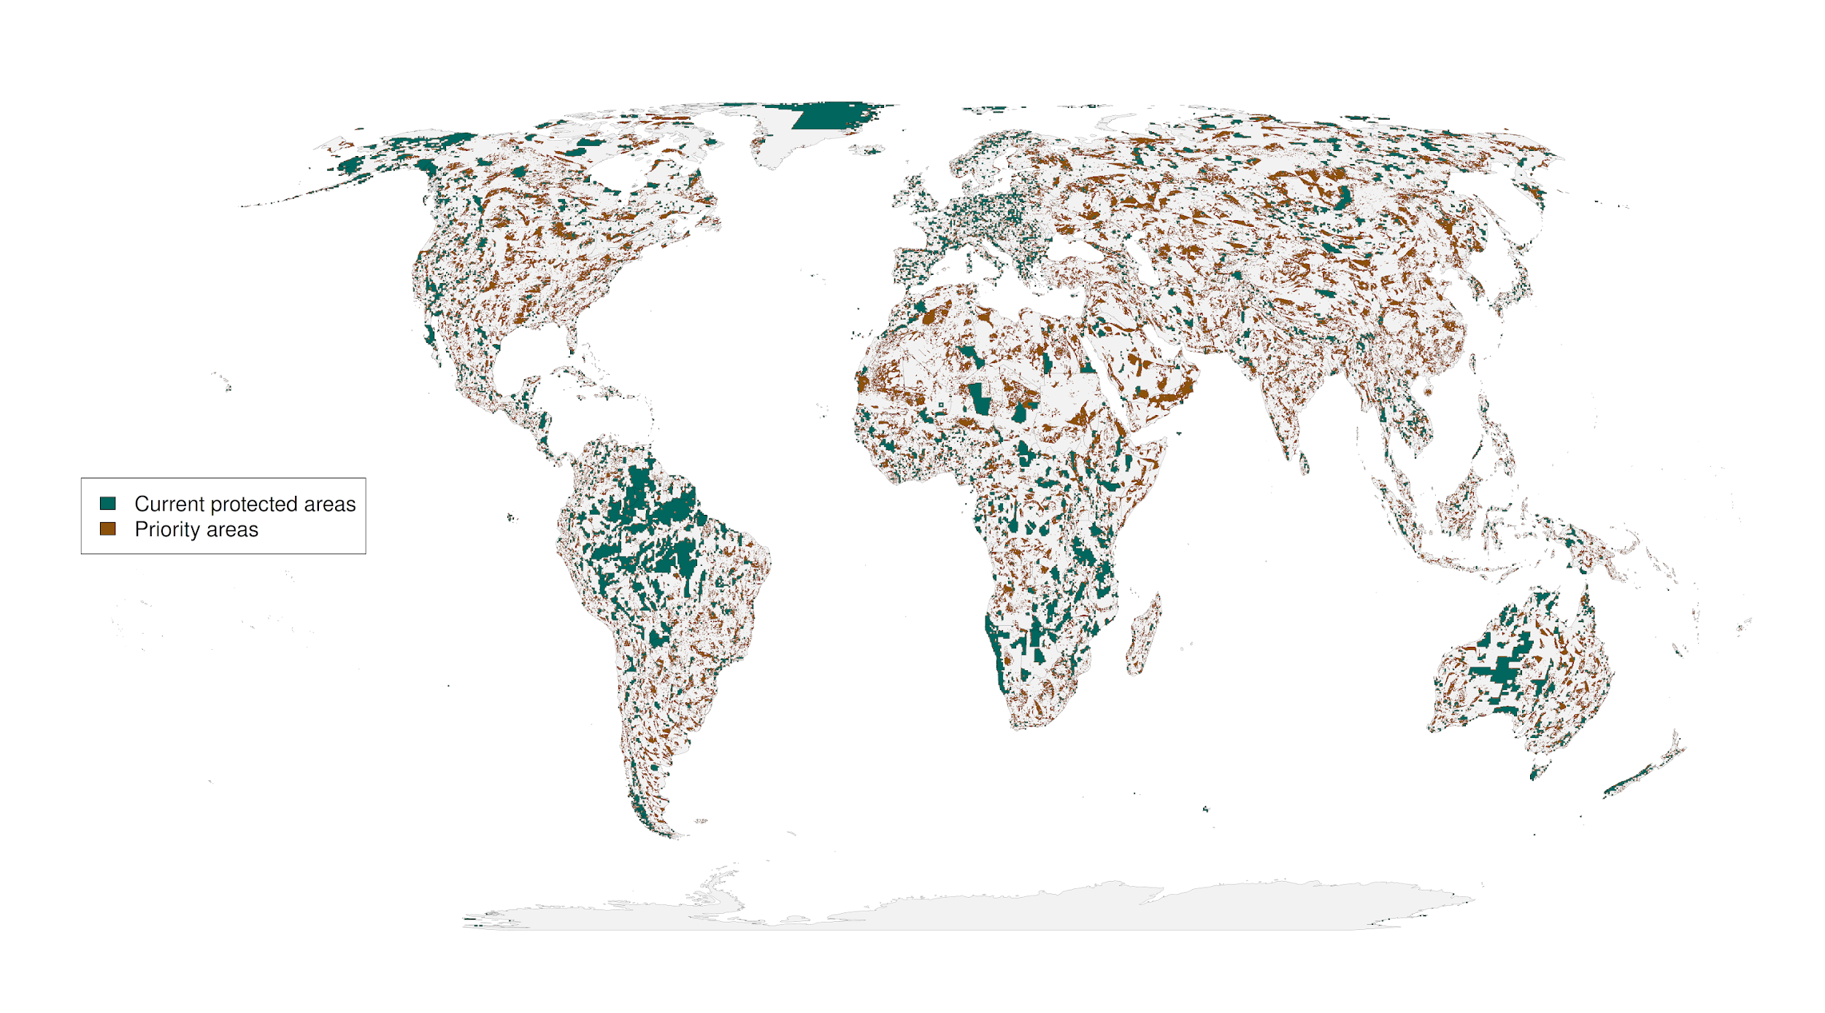

Figure 2: “No regrets” areas comprising 3.57 million km2 of land that was identified as priority habitat for protection regardless of the risks included in our analysis.

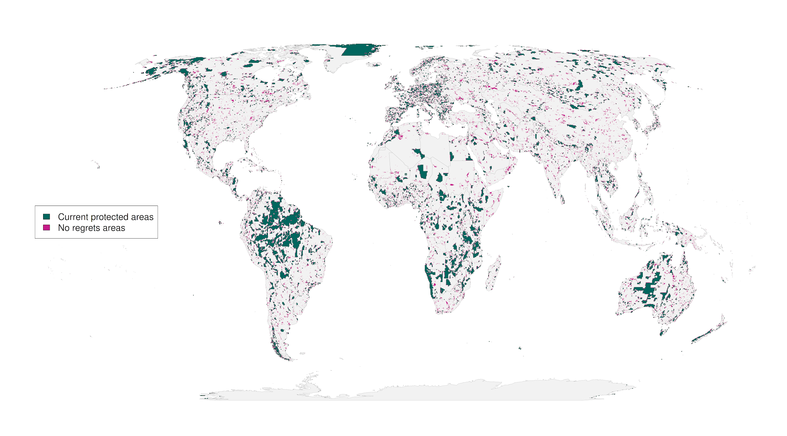

Figure 3: Percent country-level variation between the baseline scenario and the 15 scenarios including risk. Countries whose results are consistent across the 15 scenarios (e.g. Brazil) have low variation, while countries whose results are less consistent across the 15 scenarios have high variation (e.g. Sweden). The kmeans method was used to generate class intervals.

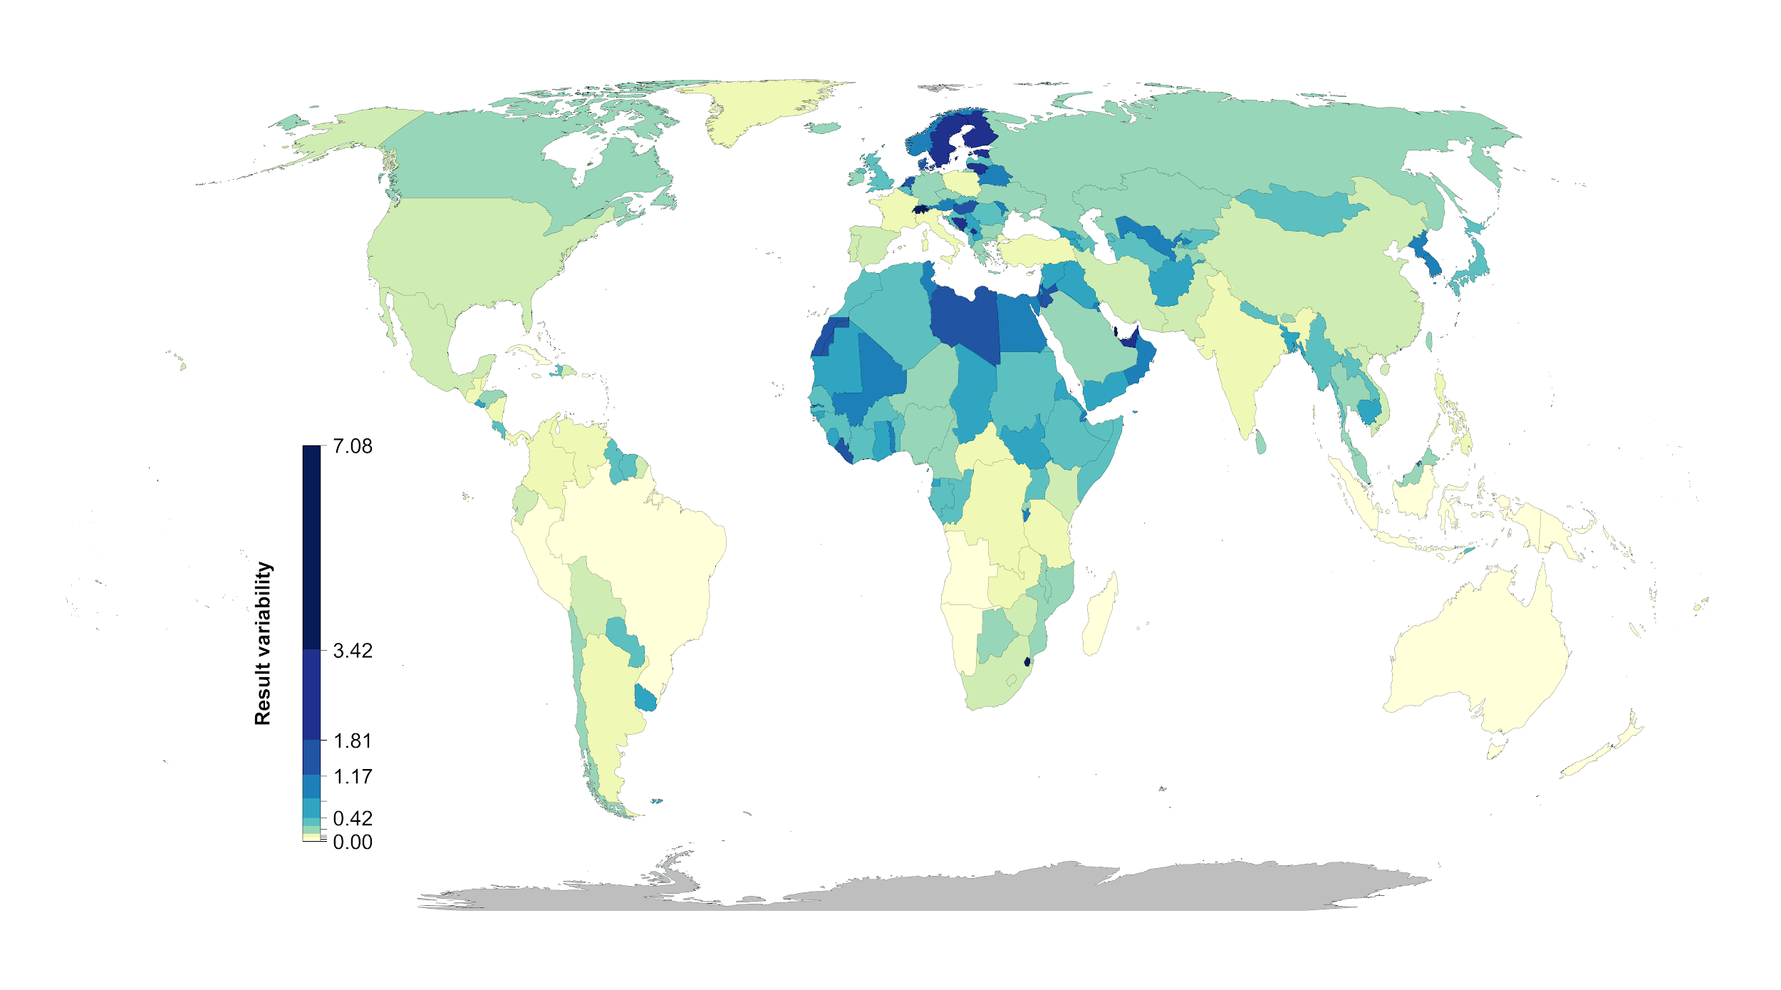

Figure 4: Contrast of using individual risk objectives (governance, land-use, climate) to the baseline scenario of uniform objective structure. In the top panels brown shows baseline, green the specific risk objective results, and purple where both scenarios agree. The figures show how the spatial configuration of the solutions changes when risk is considered in a scenario. The bottom panels represent the individual risk data for the focal regions. Governance focus is on Sweden, Finland and Russia, land-use risk on Sierra Leone and Liberia, and climate risk on Algeria and Liberia.

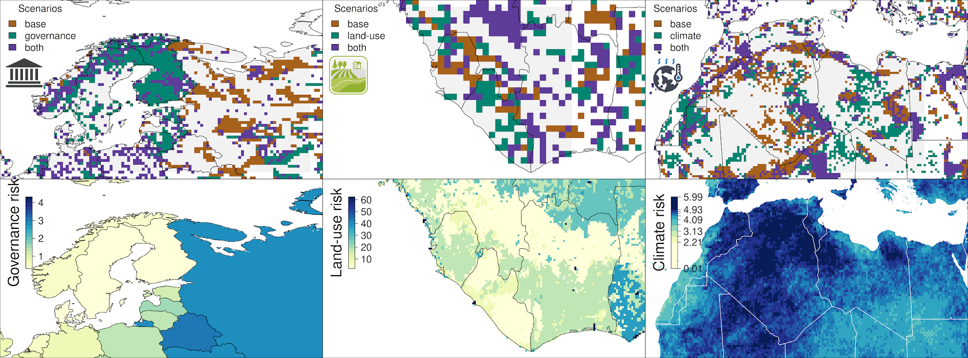

**Methods**

We used a multi-objective optimization approach that incorporated governance, land use and climate constraints to prioritize the conservation of 30,930 vertebrate species. All scenarios we investigated assumed the current global protected area portfolio is locked in. We further set a target to protect 30% of the range of each species, which is broadly analogous to current CDB discussions on post-2020 biodiversity targets4.

*Species selection*

Our species list included all terrestrial vertebrate species from the IUCN Red List of threatened species, following Pouzols et al.2. For mammal, amphibian and reptile species ranges, we used the IUCN Red List website (<http://www.iucnredlist.org/>, accessed 2019-11-14) and for birds we used the BirdLife International data zone webpage (<http://www.birdlife.org/datazone/home>, accessed 2019-11-14). We used these taxa because no analogous data are available for a high proportion of species in other taxonomic groups such as insects33. These data have certain limitations, including possible underestimation of the extent of occurrence and overestimation of the true area of occupancy2, but they have been shown to be robust to commission errors as long as the focus is on species assemblages rather than single species7. They are currently the most frequently used and updated source for vertebrate species distributions34.

For each taxonomic group, we restricted our analysis to species that fell into the presence category of ‘Extant’, the origin categories of ‘Native’ or ‘Reintroduced’ and the seasonality categories ‘Resident’, ‘Breeding Season’ or ‘Non-breeding Season’, thus only focusing on stationary periods of the life cycle of migratory species. This resulted in the following final numbers of amphibian, bird, mammal and reptile species ranges: 5660, 13375, 5442, and 6153, respectively.

*Basic administrative delineations*

National boundaries were derived from the Global Administrative Areas database (<http://gadm.org/>, accessed 2019-10-31). We obtained protected area boundaries from the World Database on Protected Areas (WDPA, [https://www.protectedplanet.net](https://www.protectedplanet.net/)). Following standard procedures for cleaning the protected area dataset35,36, we (i) projected the data to an equal-area coordinate system (World Behrman), (ii) excluded reserves with unknown or proposed designations, (iii) excluded UNESCO Biosphere Reserves37, (iv) buffered sites represented as point localities to their reported area, (v) dissolved boundaries to prevent issues with overlapping areas, and (vi) removed slivers (code available at https://github.com/jeffreyhanson/global-protected-areas). After the protected area data were modified as described above, we overlaid the protected area boundaries with a 10 x 10 km grid covering the Earth. These spatial data procedures were implemented using ArcMap (version 10.3.1) and python (version 2.7.8).

*Governance risk*

Conservation risk due to governance can affect the outcomes of strategies, and effective governance can promote the resilience of conservation in the face of sociopolitical and economic shocks. We used worldwide governance indicators from the World Bank15 to capture these pressures. The indicators include six scaled measures: voice and accountability; political stability and absence of violence; government effectiveness; regulatory quality; rule of law; and control of corruption (see Table S4 for definitions). We chose these indicators because evidence suggests that they reliably predict protected area effectiveness38 and state investment and efforts for biodiversity conservation8. For each country, we used a mean of annual averages of all six measures8 (Figure S1).

*Land use risk*

We used a recently developed global land systems map produced by Kehoe et al.16 to incorporate the risk of land-use change. This map is based on a global land systems map for the year 200039 at a 9.25 km2 spatial resolution, but is refined based on recent land-cover and land-use datasets to a spatial resolution of 1 km2. Kehoe et al.16 further estimated the impact of land use and land use intensity on biodiversity, with data originating from the PREDICTS project40. They first matched their land-systems classes to varying intensity levels for each land-use type (for detailed conversion table, see ref41). This allowed Kehoe et al.16 to calculate average biodiversity loss per land system (relative to an unimpacted baseline) by taking the mean model estimates of biodiversity loss per land-use intensity class from previous work41. The result gives average relative biodiversity gain or loss per land-system class. Here, we used their modelled mean estimates (following Newbold et al.41) of relative percent biodiversity change for each land-system class for species abundance as a measure of the land-use pressure (Figure S2).

*Climate risk*

We estimated climatic risk based on the estimated trend in the annual proportion of days containing extreme heat events from 1979 to 201917. Extreme heat events were estimated using hourly air temperature at 2 m above the surface and gridded at a 31 km (0.28125° at the equator) spatial resolution (DOI: 10.24381/cds.adbb2d47). The temperature data was acquired from the European Centre for Medium-Range Weather Forecasts (ECMWF) fifth generation atmospheric reanalysis of the global climate (ERA5)42,43. The approach first extracted daily minimum and maximum temperature for each grid cell over the 41-year period. To reduce the influence of warming trends, the daily minimum and maximum temperature was then detrended across years for each day and grid cell using empirical mode decomposition (EMD)44,45. The occurrence of extreme heat events was estimated using the following approach: The detrended minimum and maximum temperature data was treated as normally distributed across years for each day and grid cell. The probability density function for the detrended minimum and maximum temperature was then estimated using the mean and standard deviation calculated across years for each day and grid cell. Extreme heat events occurred when the probabilities for both minimum and maximum temperature on a given day and grid cell were within the 0.95-1.00 quartile of the probability density function. The trend in the annual proportion of days containing extreme heat events for each year was calculated for each grid cell using beta regression with a logit link function and an identity function in the precision model46,47. (Figure S3). See La Sorte et al.17 for additional details.

*Multi-objective optimization of pressure reduction*

We processed all data described previously to a 10 x 10 km resolution and clipped data to the extent of land based on the global administrative areas database. We then developed an extension on the minimum set problem, which has the goal to identify a set of sites within a planning area that represents all conservation targets in the fewest number of sites21. Instead of including one objective we expanded the formulation to include multiple objectives in the problem formulation. We used a hierarchical or lexicographic approach that assigns a priority to each objective, and optimizes for the objectives in decreasing priority order. At each step, it finds the best solution for the current objective, but only from among those that would not degrade the solution quality for higher-priority objectives. We considered up to three objectives in our prioritization scenarios, i) governance risk, ii) land-use risk, and iii) climate risk. To compare different scenarios, we calculated solutions for each unique objective combination (n = 15), as well as one where we use a constant objective function as the base scenario, as the order of the hierarchy can influence the results.

In systematic conservation planning, conservation features describe the biodiversity units (e.g. species, communities, habitat types) that are used to inform protected area establishment. Planning units describe the candidate areas for protected area establishment (e.g. cadastral units). Each planning unit contains an amount of each feature (e.g. presence/absence, number of individuals). A prioritization describes a candidate set of planning units selected for protected establishment. Each feature has a representation target indicating the minimum amount of each feature that ideally should be held in the prioritization (e.g. 50 presences, 200 individuals). To minimize risk, we have a set of datasets describing the relative risk associated with selecting each planning unit for protected area establishment. Thus we wish to identify a prioritization that meets the representation targets for all of the conservation features, with minimal risk.

Let I denote the set of conservation features (indexed by i), and J denote the set of planning units (indexed by j). To describe existing conservation efforts, let pj indicate (i.e., using zeros and ones) if each planning unit j ∈ J ia already part of the global protected area system. To describe the spatial distribution of the features, let Aij denote (i.e., using zeros and ones) if each feature is present or absent from each planning unit. To ensure the features are adequately represented by the solution, let Ti denote the conservation target for each feature i ∈ I. Next, let D denote the set of risk datasets (indexed by d). To describe the relative risk associated with each planning unit, let Rdj denote the risk for planning units j ∈ J according to risk datasets d ∈ D.

The problem contains the binary decision variables xj for planning units j ∈ J.

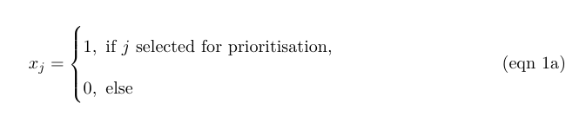

The reserve selection problem is formulated following:

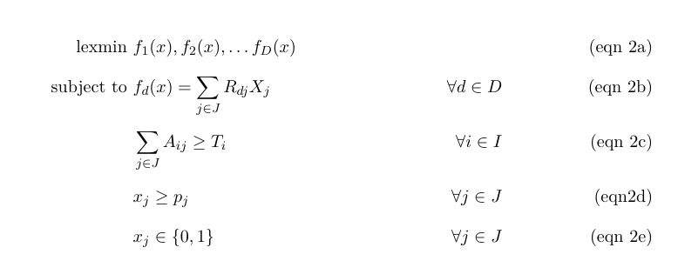

The objective function (eqn 2a) is to lexicographically (hierarchically) minimize multiple functions. Constraints (eqn 2b) define each of these functions as the total risk encompassed by selected planning units given each risk dataset. Constraints (eqn 2c) ensure that the representation targets (Ti ) are met for all features. Constraints (eqn 2d) ensure that the existing protected areas are selected in the

solution. Finally, constraints (eqns 2e) ensure that the decision variables xj contain zeros or ones.

For all scenarios we locked in current protected areas and used the same feature set of 30,930 vertebrates. The target for each feature was set to 30% of their range. The optimality gap, which specifies how far from numerical optimality we would allow the solution to be, we use was 10% for each objective in the hierarchy. We chose a 10% optimality gap to allow for some flexibility in the result of each step in the hierarchy to avoid getting too restricted in the solution space.

**Methods references**

**Acknowledgements**

V. Tulloch was supported by a Postdoctoral Research Grant from Environment and Climate Change Canada (ECCC). J. Bennett was funded by the Natural Sciences and Engineering Research Council of Canada (NSERC) and ECCC.

**Author contributions**

**Competing interest declaration**

**Table S1.** Scenarios explored and global protection results. The risk factor order represents the order risk factors were included in the hierarchical prioritization. (G = governance, L = land use, C = Climate).

|  |  |  |
| --- | --- | --- |
| **Scenario** | **Risk factors included** | **Global land area protected [%]** |
| **baseline** | - | 28.08 |
| **1** | G | 28.44 |
| **2** | L | 29.23 |
| **3** | C | 28.45 |
| **4** | G > L | 29.2 |
| **5** | L > G | 29.23 |
| **6** | G > C | 28.43 |
| **7** | C > G | 28.45 |
| **8** | L > C | 29.19 |
| **9** | C > L | 29.19 |
| **10** | G > L > C | 29.17 |
| **11** | G > C > L | 29.2 |
| **12** | L > G > C | 29.19 |
| **13** | L > C > G | 29.19 |
| **14** | C > G > L | 29.2 |
| **15** | C > L > G | 29.19 |

**Table S2**. Country specific results for the 15 scenarios investigated. Numbers represent % of land area of a country selected.  
(As an example 5 countries included here, full list in csv)   
<https://drive.google.com/file/d/1eD4y4K8XG4nxnRL5fNtiTqzuqfIJ_DfB/view?usp=sharing>

|  |  |  |  |  |  |
| --- | --- | --- | --- | --- | --- |
|  | Afghanistan | Akrotiri and Dhekelia | Åland | Albania | Algeria |
| A | 22.99 | 50 | 0 | 19.1 | 32.65 |
| S | 15.93 | 100 | 100 | 17.36 | 20.54 |
| L | 26.65 | 50 | 33.33 | 21.88 | 29.8 |
| C | 23.1 | 50 | 0 | 19.79 | 27.53 |
| SL | 26.58 | 50 | 8.33 | 21.88 | 30.01 |
| LS | 26.58 | 50 | 25 | 21.88 | 29.81 |
| SC | 15.93 | 50 | 58.33 | 17.36 | 21.03 |
| CS | 23.1 | 50 | 0 | 19.79 | 27.53 |
| LC | 26.54 | 50 | 16.67 | 21.18 | 30.84 |
| CL | 26.58 | 50 | 0 | 21.88 | 30.78 |
| SLC | 26.52 | 50 | 8.33 | 21.53 | 30.88 |
| SCL | 26.57 | 50 | 0 | 21.88 | 30.69 |
| LSC | 26.54 | 50 | 16.67 | 21.18 | 30.84 |
| LCS | 26.54 | 50 | 16.67 | 21.18 | 30.84 |
| CSL | 26.55 | 50 | 0 | 21.88 | 30.76 |
| CLS | 26.58 | 50 | 0 | 21.88 | 30.78 |

**Table S3. Governance risk score table (see csv)**<https://drive.google.com/file/d/1g_LePBfCbphXzTiCOXCzQtNLSSYoV6me/view?usp=sharing>

**Table S4.**

|  |  |
| --- | --- |
| **Indicator** | **Definition**  Source: World Bank, 2020 (<https://datacatalog.worldbank.org/dataset/worldwide-governance-indicators>) |
| Voice and accountability | “Voice and accountability captures perceptions of the extent to which a country's citizens are able to participate in selecting their government, as well as freedom of expression, freedom of association, and a free media.” |
| Political stability and absence of violence | “Political Stability and Absence of Violence/Terrorism measures perceptions of the likelihood of political instability and/or politically-motivated violence, including terrorism.” |
| Government effectiveness | “Government effectiveness captures perceptions of the quality of public services, the quality of the civil service and the degree of its independence from political pressures, the quality of policy formulation and implementation, and the credibility of the government's commitment to such policies.” |
| Regulatory quality | “Regulatory quality captures perceptions of the ability of the government to formulate and implement sound policies and regulations that permit and promote private sector development.” |
| Rule of law | “Rule of law captures perceptions of the extent to which agents have confidence in and abide by the rules of society, and in particular the quality of contract enforcement, property rights, the police, and the courts, as well as the likelihood of crime and violence.” |
| Control of corruption | “Control of corruption captures perceptions of the extent to which public power is exercised for private gain, including both petty and grand forms of corruption, as well as "capture" of the state by elites and private interests.” |

**Figure S1. Governance risk (yellow = low, blue= high)**

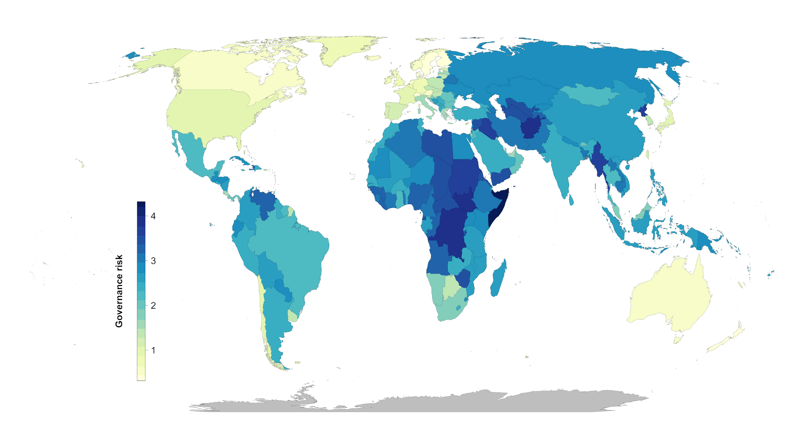

**Figure S2. Land systems risk (yellow = low, blue= high)**

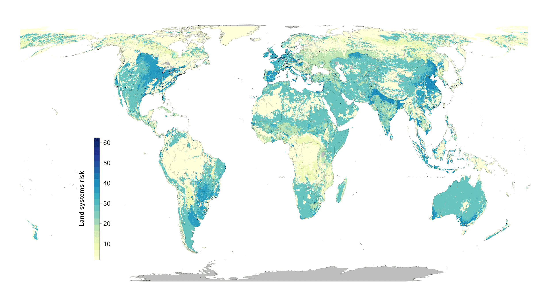

**Figure S3. Climate risk (extreme heat events) (yellow = low, blue= high)**

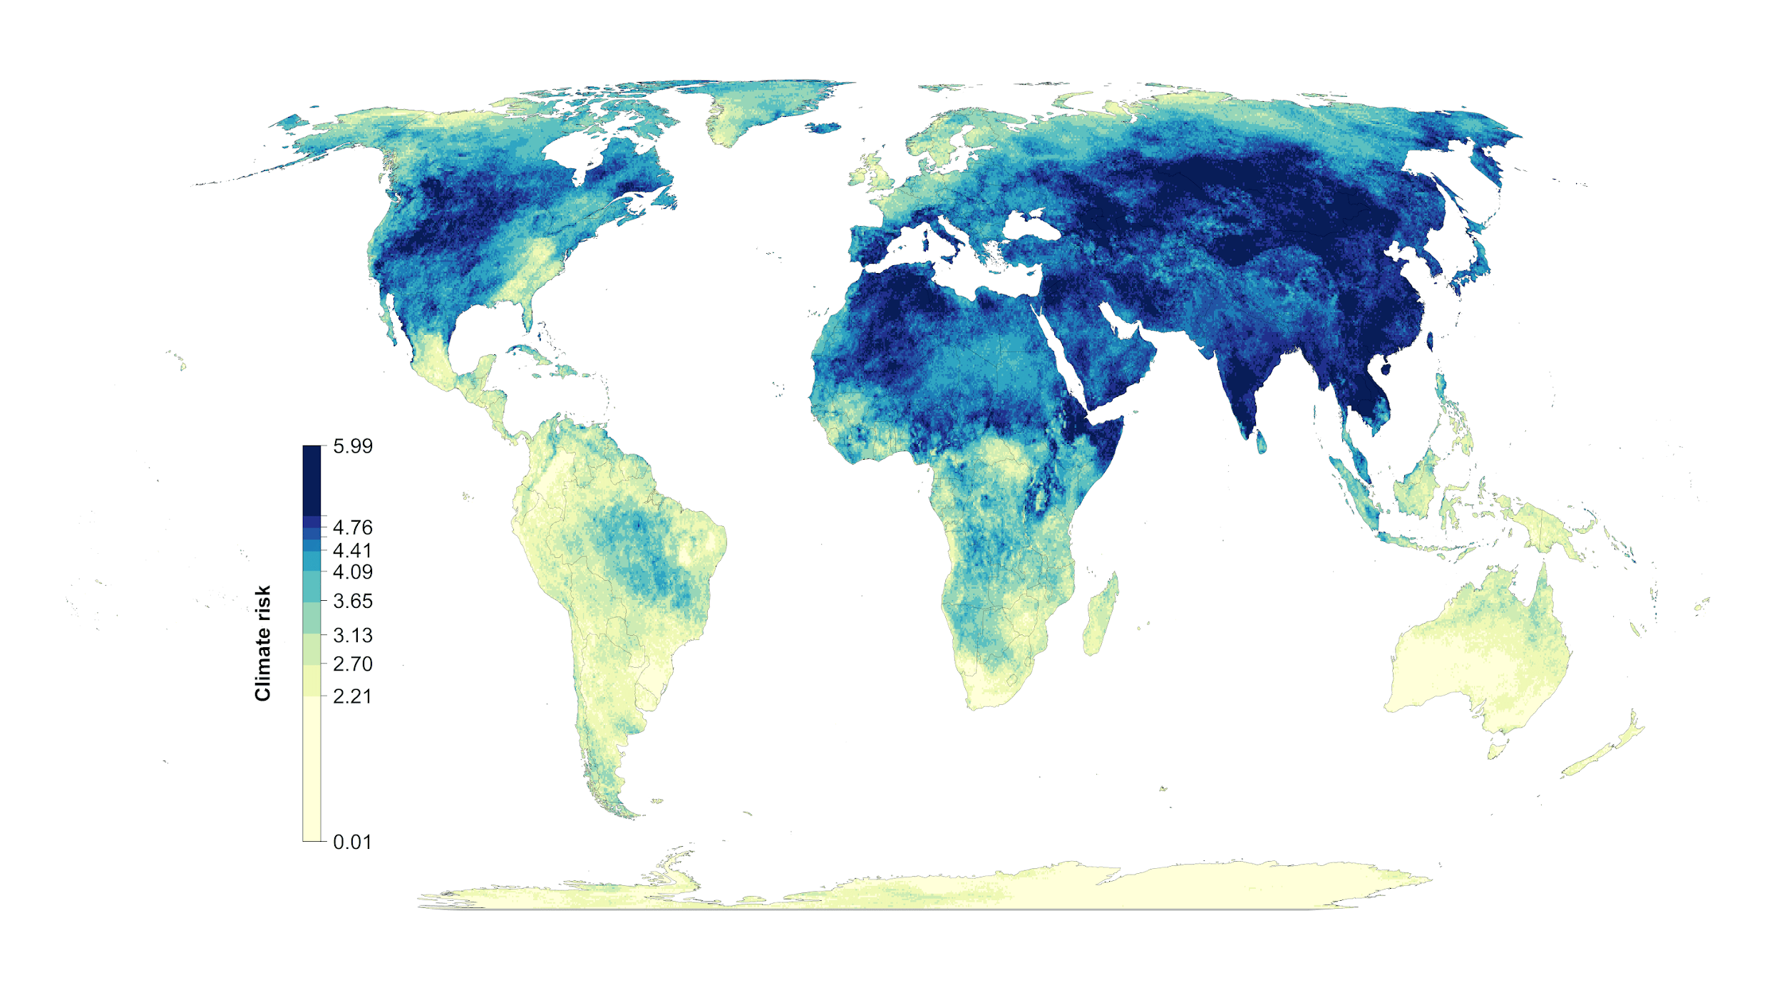

**Figure S4: Scenario overlap. green = protected areas. Color gradient from yellow (one scenario) to red (15 scenarios) = ovelap.**

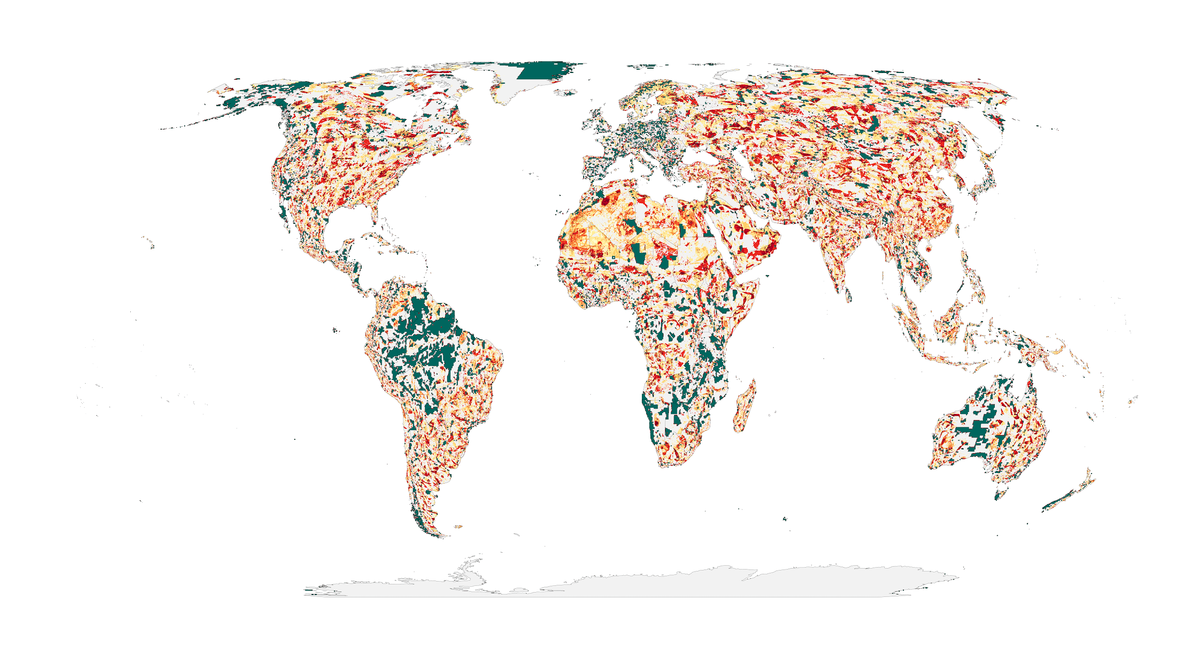

**Figure S5. Areas of high scenario overlap (>10 scenarios, green) compared to Meyers et al. biodiversity hotspots (blue).**

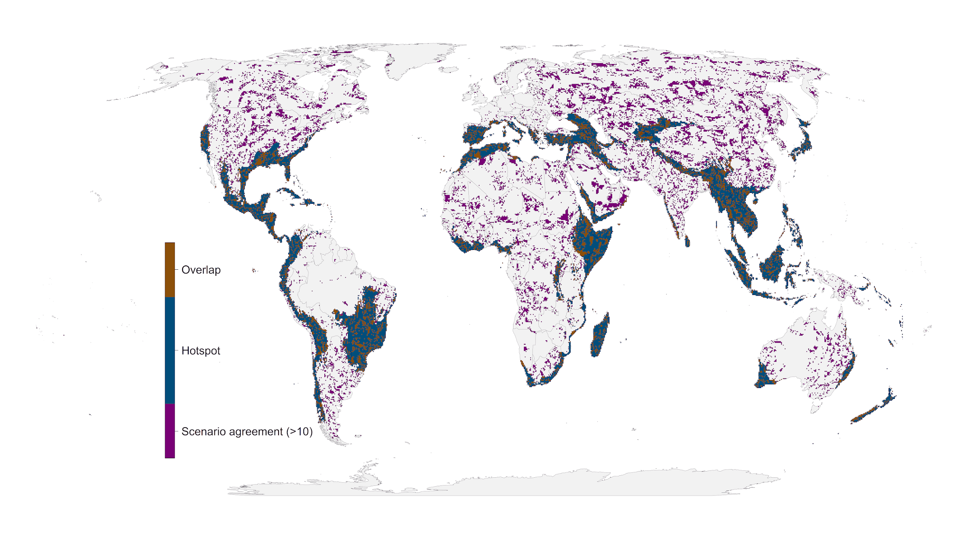

**Figure S6: Influence of average country specific risk factors on the optimization outcomes compared between baseline scenario and the scenarios including one of the risk factors. Each data point represents the results for one country. The fitted blue lines and 95% confidence bands are from ordinary least-squares regression.**

